Piyush Pancholi , 12041050

Reflog and log file outputs :

piyush@piyush-VivoBook-ASUSLaptop-:~/sem4/temp6/Wordibble$ git log --oneline –graph
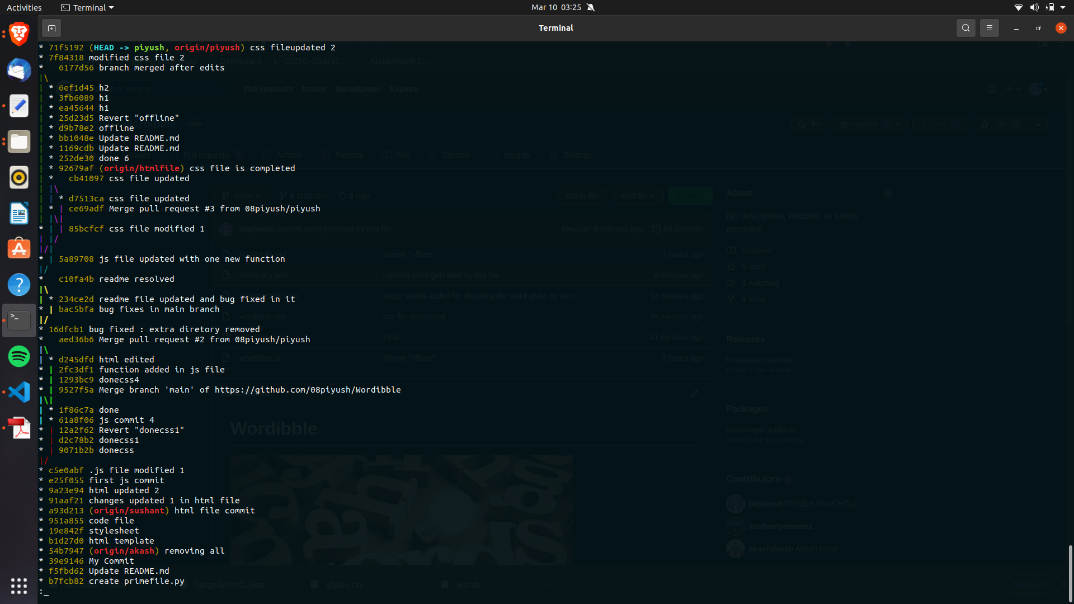

* 92679af (HEAD -> main, origin/main, origin/htmlfile, origin/HEAD) css file is completed
* cb41097 css file updated
|\
| * d7513ca css file updated
* | ce69adf Merge pull request #3 from 08piyush/piyush
|\|
| * 5a89708 (origin/piyush) js file updated with one new function
|/
* c10fa4b readme resolved
|\
| * 234ce2d readme file updated and bug fixed in it
* | bac5bfa bug fixes in main branch
|/
* 16dfcb1 bug fixed : extra diretory removed
* aed36b6 Merge pull request #2 from 08piyush/piyush
|\
| * d245dfd html edited
* | 2fc3df1 function added in js file
* | 1293bc9 donecss4
* | 9527f5a Merge branch 'main' of https://github.com/08piyush/Wordibble
|\|
| * 1f86c7a done
:...skipping...
* 92679af (HEAD -> main, origin/main, origin/htmlfile, origin/HEAD) css file is completed
* cb41097 css file updated
|\
| * d7513ca css file updated
* | ce69adf Merge pull request #3 from 08piyush/piyush
|\|
| * 5a89708 (origin/piyush) js file updated with one new function
|/
* c10fa4b readme resolved
|\
| * 234ce2d readme file updated and bug fixed in it
* | bac5bfa bug fixes in main branch
|/
* 16dfcb1 bug fixed : extra diretory removed
* aed36b6 Merge pull request #2 from 08piyush/piyush
|\
| * d245dfd html edited
* | 2fc3df1 function added in js file
* | 1293bc9 donecss4
* | 9527f5a Merge branch 'main' of https://github.com/08piyush/Wordibble
|\|
| * 1f86c7a done
| * 61a8f06 js commit 4
* | 12a2f62 Revert "donecss1"
* | d2c78b2 donecss1
* | 9071b2b donecss
|/
* c5e0abf .js file modified 1
* e25f055 first js commit
* 9a23e94 html updated 2
* 91aaf21 changes updated 1 in html file
* a93d213 (origin/sushant) html file commit
* 951a855 code file
* 19e842f stylesheet
* b1d27d0 html template
* 54b7947 (origin/akash) removing all
* 39e9146 My Commit
* f5fbd62 Update README.md
* b7fcb82 create primefile.py
* de9d8a6 Initial commit
~
~
~
~

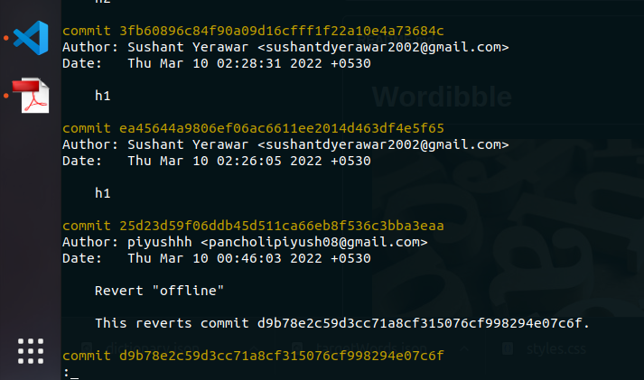

* 92679af (HEAD -> main, origin/main, origin/htmlfile, origin/HEAD) css file is completed
* cb41097 css file updated
|\
| * d7513ca css file updated
* | ce69adf Merge pull request #3 from 08piyush/piyush
|\|
| * 5a89708 (origin/piyush) js file updated with one new function
|/
* c10fa4b readme resolved
|\
| * 234ce2d readme file updated and bug fixed in it
* | bac5bfa bug fixes in main branch
|/
* 16dfcb1 bug fixed : extra diretory removed
* aed36b6 Merge pull request #2 from 08piyush/piyush
|\
| * d245dfd html edited
* | 2fc3df1 function added in js file
* | 1293bc9 donecss4
* | 9527f5a Merge branch 'main' of https://github.com/08piyush/Wordibble
|\|
| * 1f86c7a done
| * 61a8f06 js commit 4
* | 12a2f62 Revert "donecss1"
* | d2c78b2 donecss1
* | 9071b2b donecss
|/
* c5e0abf .js file modified 1
* e25f055 first js commit
* 9a23e94 html updated 2
* 91aaf21 changes updated 1 in html file
* a93d213 (origin/sushant) html file commit
* 951a855 code file
* 19e842f stylesheet
* b1d27d0 html template
* 54b7947 (origin/akash) removing all
* 39e9146 My Commit
* f5fbd62 Update README.md
* b7fcb82 create primefile.py
* de9d8a6 Initial commit
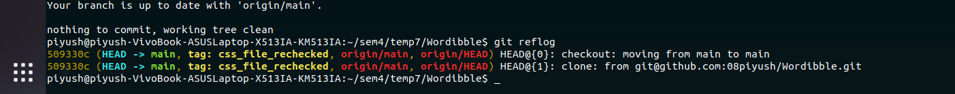
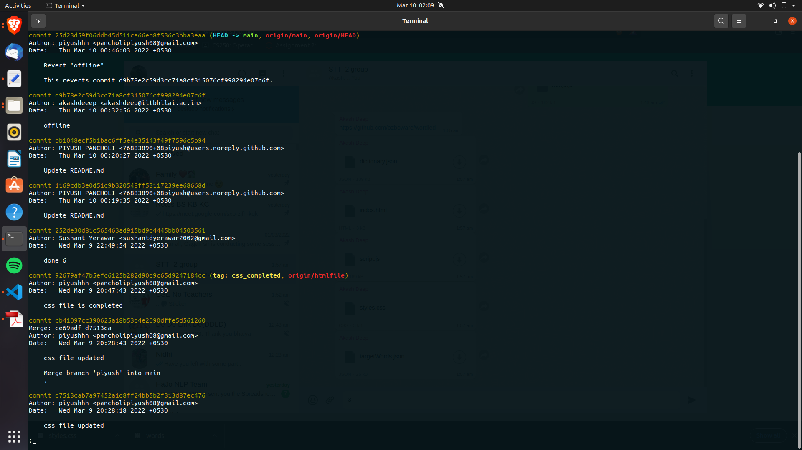

commit 92679af47b5efc6125b282d90d9c65d9247184cc (HEAD -> main, tag: css_file_completed, origin/main, origin/HEAD)
Author: piyushhh <pancholipiyush08@gmail.com>
Date: Wed Mar 9 20:47:43 2022 +0530

css file is completed

commit cb41097cc390625a18b53d4e2090dffe5d561260
Merge: ce69adf d7513ca
Author: piyushhh <pancholipiyush08@gmail.com>
Date: Wed Mar 9 20:28:43 2022 +0530

css file updated

Merge branch 'piyush' into main
.

commit d7513cab7a97452a1d8ff24bb5b2f313d87ec476
Author: piyushhh <pancholipiyush08@gmail.com>
Date: Wed Mar 9 20:28:18 2022 +0530

css file updated

commit ce69adf2b9c03705cc997771ef5c188ac28b2058
Merge: c10fa4b 5a89708
Author: PIYUSH PANCHOLI <76883890+08piyush@users.noreply.github.com>
Date: Wed Mar 9 20:11:18 2022 +0530

Merge pull request #3 from 08piyush/piyush

js file updated with one new function

5a89708 (HEAD -> piyush, origin/piyush, main) HEAD@{0}: reset: moving to 5a89708
d7513ca HEAD@{1}: checkout: moving from main to piyush
5a89708 (HEAD -> piyush, origin/piyush, main) HEAD@{2}: reset: moving to 5a89708
d7513ca HEAD@{3}: reset: moving to d7513ca
d7513ca HEAD@{4}: reset: moving to d7513ca
cb41097 (origin/main, origin/HEAD) HEAD@{5}: merge piyush: Merge made by the 'recursive' strategy.
ce69adf HEAD@{6}: checkout: moving from piyush to main
d7513ca HEAD@{7}: commit: css file updated
5a89708 (HEAD -> piyush, origin/piyush, main) HEAD@{8}: checkout: moving from main to piyush
ce69adf HEAD@{9}: clone: from git@github.com:08piyush/Wordibble.git

commit 2acf56617a26245877cf3d0f034b71c2bdda92b1 (HEAD -> piyush, main)
Author: piyushhh <pancholipiyush08@gmail.com>
Date: Wed Mar 9 20:17:28 2022 +0530

bug fixed in css file

commit cdeccb0897d7a5f3b047258c0625dd548d12ab1e
Author: piyushhh <pancholipiyush08@gmail.com>
Date: Wed Mar 9 20:15:32 2022 +0530

css file updated

commit 5a897082d6bf59c7648cf29d390c9c7988f3f3f5 (origin/piyush)
Author: piyushhh <pancholipiyush08@gmail.com>
Date: Wed Mar 9 20:09:50 2022 +0530

js file updated with one new function

commit c10fa4b316fb69a030dc63390b248ebe7ffd721f (origin/main, origin/HEAD)
Merge: bac5bfa 234ce2d
Author: piyushhh <pancholipiyush08@gmail.com>
Date: Wed Mar 9 13:17:03 2022 +0530

readme resolved

commit bac5bfacbf653d7be36ce07c55edf46a01f42890
Author: piyushhh <pancholipiyush08@gmail.com>
Date: Wed Mar 9 13:14:51 2022 +0530

bug fixes in main branch

commit 234ce2d44751ab5d2e53bdc00661a5f96064d205
Author: piyushhh <pancholipiyush08@gmail.com>
Date: Wed Mar 9 13:13:06 2022 +0530

readme file updated and bug fixed in it

commit 16dfcb18dce4bdb42d11a247057478a6e7058199
Author: piyushhh <pancholipiyush08@gmail.com>
Date: Wed Mar 9 13:08:58 2022 +0530

bug fixed : extra diretory removed

commit aed36b6333f4471a3ea6a77b8e21495b1168bd49
Merge: 2fc3df1 d245dfd
Author: PIYUSH PANCHOLI <76883890+08piyush@users.noreply.github.com>
Date: Wed Mar 9 12:40:37 2022 +0530

Merge pull request #2 from 08piyush/piyush

html edited

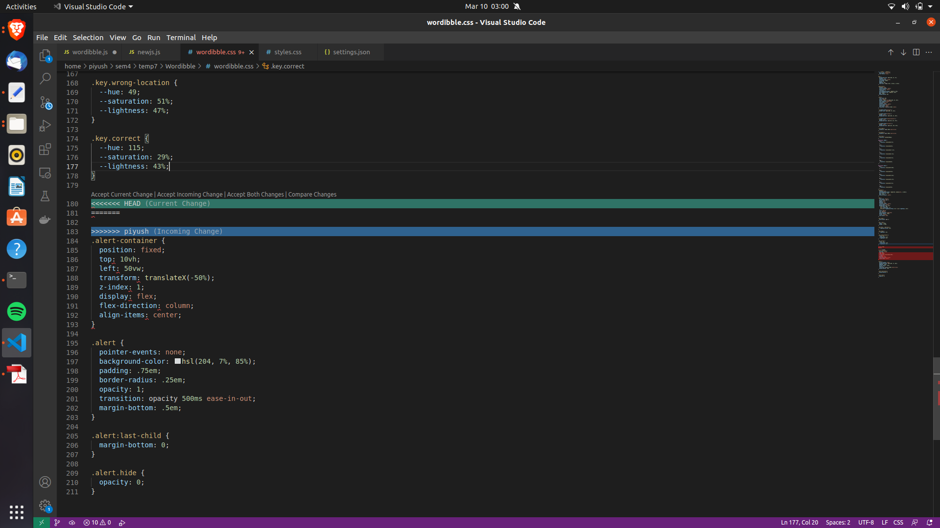
merge conflicts

